Stage 3

**Tittle : "Evaluation and Optimization of IBM's SOC and SIEM Tools for Enhanced Security Operations"**

This project aims to assess the efficacy, capabilities, and operational efficiency of IBM's Security Operations Center (SOC) and Security Information and Event Management (SIEM) tools in mitigating cyber threats and fortifying organizational security. The study will delve into an in-depth analysis of IBM's SOC and SIEM tools, exploring their functionalities, features, and integration capabilities within diverse network environments. Moreover, the project seeks to optimize the utilization of these tools to enhance proactive threat detection, incident response, and overall security posture.

**Objectives:**

1. Conduct a comprehensive review of IBM's SOC and SIEM tools, including their functionalities, deployment options, and compatibility with various IT infrastructures.
2. Evaluate the effectiveness of these tools in real-time threat detection, log management, correlation of security events, and incident response.
3. Compare IBM's SOC and SIEM tools with industry standards and competitor offerings to identify strengths, weaknesses, opportunities, and potential areas of improvement.
4. Implement a test environment to simulate various cyber threat scenarios and assess the tools' capabilities in detecting, alerting, and mitigating these threats.
5. Develop strategies and recommendations for optimizing the utilization of IBM's SOC and SIEM tools based on the evaluation outcomes.

**SOC and SOC Cycle :**

**SOC:**

Security Operations Center (SOC) plays a pivotal role in safeguarding an organization's digital assets and infrastructure from potential cyber threats. The SOC operates as a centralized unit that monitors, detects, analyzes, responds to, and mitigates cybersecurity incidents on an ongoing basis.

The SOC Cycle typically involves the following key stages:

1. Threat Detection and Prevention:

Monitoring: Constant monitoring of networks, systems, applications, and endpoints using various security tools and technologies like SIEM (Security Information and Event Management), IDS/IPS (Intrusion Detection and Prevention Systems), firewalls, etc.

Threat Intelligence: Gathering and analyzing threat intelligence feeds to stay updated about potential cyber threats, vulnerabilities, and attack patterns.

Vulnerability Management: Identifying and assessing vulnerabilities within the organization's IT environment to proactively address weaknesses before they can be exploited.

2. Incident Identification and Analysis:

Alert Triage: Analyzing alerts generated by security tools to determine the severity and validity of potential security incidents.

Incident Investigation: Conducting in-depth analysis and investigation of confirmed security incidents to understand the nature, scope, and impact of the threat.

Forensic Analysis: Gathering and preserving evidence for further analysis, attribution, and potential legal proceedings.

3. Incident Response and Mitigation:

Containment: Taking immediate actions to contain the incident and prevent further spread or damage.

Eradication: Removing the root cause of the incident from the affected systems and networks.

Recovery: Restoring affected systems and data to their normal operational state.

Lessons Learned: Conducting post-incident reviews to identify weaknesses in the security posture and improve response procedures for future incidents.

4. Continuous Improvement:

Metrics and Reporting: Tracking key performance indicators (KPIs) to measure the effectiveness and efficiency of the SOC operations.

Feedback Loop: Incorporating lessons learned from incidents into security policies, procedures, and training programs.

Technology and Process Enhancement: Upgrading security tools, refining processes, and adapting strategies to stay ahead of evolving threats.

The SOC operates in a continuous cycle, as cybersecurity is an ongoing process that requires constant vigilance, adaptation, and improvement. The SOC's effectiveness relies not only on technology but also on skilled personnel, robust processes, and collaboration across various departments within an organization to ensure a proactive and resilient security posture.

**SIEM and SIEM Cycle :**

**SIEM :**

SIEM stands for Security Information and Event Management. It refers to a comprehensive approach to security management that combines SIM (Security Information Management) and SEM (Security Event Management) functionalities. SIEM systems provide a centralized platform for collecting, analyzing, and managing security-related data from various sources within an organization's IT infrastructure.

The SIEM Cycle typically involves the following key stages:

1. Data Collection:

Log Collection: Gathering logs and security-related data from diverse sources such as network devices, servers, applications, endpoints, security tools, and more.

Normalization: Standardizing and normalizing collected data into a common format for consistent analysis and correlation.

Aggregation: Aggregating and storing the normalized data in a centralized repository for further analysis and correlation.

2. Event Correlation and Analysis:

Real-Time Monitoring: Analyzing incoming events and logs in real-time to identify potential security incidents or suspicious activities.

Correlation: Correlating disparate security events and logs to detect patterns or relationships that may indicate a security threat.

Alert Generation: Generating alerts or notifications for security analysts or SOC teams based on predefined rules or anomalies detected during correlation.

3. Threat Detection and Incident Response:

Incident Prioritization: Prioritizing alerts based on severity, impact, and relevance to the organization's security posture.

Investigation and Analysis: Investigating identified incidents to understand the scope, impact, and root cause of security threats.

Response Orchestration: Initiating and coordinating appropriate response actions to contain, mitigate, or eradicate the security incident.

4. Forensic Analysis and Reporting:

Forensic Investigation: Conducting detailed forensic analysis to gather evidence, identify the attack vector, and aid in remediation efforts.

Reporting and Compliance: Generating reports for compliance purposes, incident documentation, and analysis of security trends or patterns.

5. Continuous Improvement:

Tuning and Optimization: Fine-tuning SIEM rules, correlations, and configurations based on the analysis of incidents and false positives.

Threat Intelligence Integration: Integrating external threat intelligence feeds to enhance the SIEM's capability to detect emerging threats.

Training and Knowledge Sharing: Providing ongoing training to analysts and SOC teams to stay updated with evolving threats and security technologies.

The SIEM Cycle is an iterative process that requires constant refinement and adaptation to effectively detect, respond to, and mitigate security threats. It serves as a critical component of an organization's cybersecurity strategy, enabling proactive threat management and incident response capabilities.

MISP :

MISP stands for Malware Information Sharing Platform & Threat Sharing. It's an open-source threat intelligence platform designed to enable sharing, storing, and correlating Indicators of Compromise (IOCs) and threat information among cybersecurity professionals and organizations. MISP serves as a centralized repository for exchanging actionable threat intelligence to improve cyber defense strategies and incident response capabilities.

Key features and functionalities of MISP include:

IOC Management: MISP allows users to collect, store, and manage various types of IOCs, such as IP addresses, domain names, hashes, email addresses, malware samples, and more.

Data Sharing and Collaboration: It facilitates the sharing of threat intelligence and IOCs among trusted communities, organizations, or teams, fostering collaboration and enabling quick dissemination of actionable information.

Automated Data Feeds: MISP supports automated data feeds from various sources, including open-source feeds, commercial feeds, and user-generated feeds, ensuring an up-to-date and comprehensive view of emerging threats.

Correlation and Analysis: The platform enables the correlation of different types of IOCs to identify potential relationships or patterns between indicators, aiding in the detection of complex and coordinated attacks.

Taxonomies and Tagging: MISP uses standardized taxonomies and tagging systems to classify and categorize threat information, enhancing consistency and interoperability between different organizations and sectors.

Integration Capabilities: It offers integration with other security tools and platforms, such as SIEMs, threat intelligence platforms, and analysis tools, allowing for seamless information sharing and automation of response actions.

Customization and Flexibility: Users can customize and extend the platform's functionalities to meet specific organizational requirements, adapt to different use cases, and support various data formats.

MISP plays a crucial role in strengthening cybersecurity defenses by facilitating the exchange of timely and relevant threat intelligence, enabling organizations to proactively defend against cyber threats and enhance their incident response capabilities through collective knowledge and shared insights.

**Our College (COER UNIVERSITY ROORKEE) Network Information :**

**Used Network Topology in Our College (Coer University Roorkee)**

Network Topology is the schematic description of a network arrangement, connecting various nodes (sender and receiver) through lines of connection.

**RING Topology**

It is called ring topology because it forms a ring as each computer is connected to another computer, with the last one connected to the first. Exactly two neighbours for each device.

**Features of Ring Topology**

1. A number of repeaters are used for Ring topology with large number of nodes, because if someone wants to send some data to the last node in the ring topology with 100 nodes, then the data will have to pass through 99 nodes to reach the 100th node. Hence to prevent data loss repeaters are used in the network.
2. The transmission is unidirectional, but it can be made bidirectional by having 2 connections between each Network Node, it is called **Dual Ring Topology**.
3. In Dual Ring Topology, two ring networks are formed, and data flow is in opposite direction in them. Also, if one ring fails, the second ring can act as a backup, to keep the network up.
4. Data is transferred in a sequential manner that is bit by bit. Data transmitted, has to pass through each node of the network, till the destination node.

**Advantages of Ring Topology**

1. Transmitting network is not affected by high traffic or by adding more nodes, as only the nodes having tokens can transmit data.
2. Cheap to install and expand

**STAR Topology**

In this type of topology all the computers are connected to a single hub through a cable. This hub is the central node and all others nodes are connected to the central node.

**Features of Star Topology**

1. Every node has its own dedicated connection to the hub.
2. Hub acts as a repeater for data flow.
3. Can be used with twisted pair, Optical Fibre or coaxial cable.

**Advantages of Star Topology**

1. Fast performance with few nodes and low network traffic.
2. Hub can be upgraded easily.
3. Easy to troubleshoot.
4. Easy to setup and modify.
5. Only that node is affected which has failed, rest of the nodes can work smoothly.

**Data Flow:**

Communication between two devices half-duplex or ful-duplex we are using ful-duplex communication

Direction of data all the time

**Station**

**Station**

**NETWORKS**

A network is a set of devices (often referred to as nodes) connected by communication links. A node can be a computer, printer, or any other device capable of sending and/or receiving data generated by other nodes on the network.

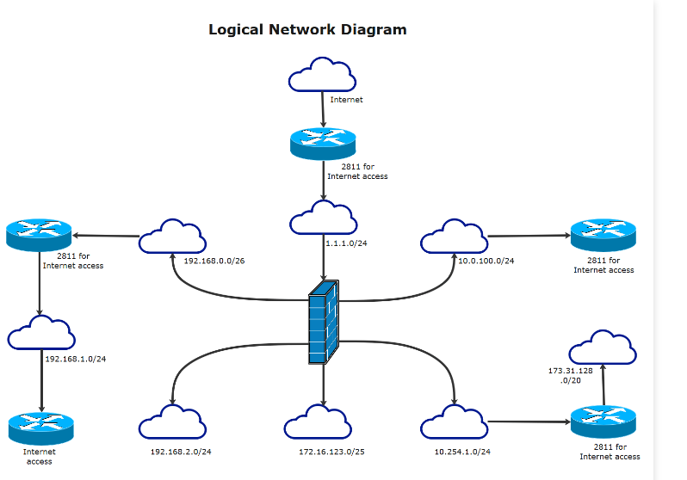

**Network Criteria**

A network must be able to meet a certain number of criteria. The most important of these are performance, reliability, and security.

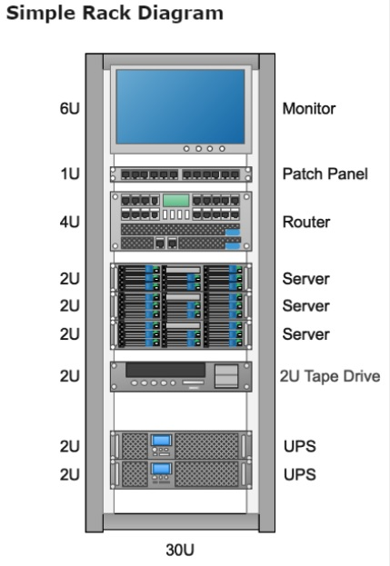**Performance:** Performance can be measured in many ways, including transit time and response time. Transit time is the amount of time required for a message to travel from one device to another. Response time is the elapsed time between an inquiry and a response. The performance of a network depends on a number of factors, including the number of users, the type of transmission medium, the capabilities of the connected hardware, and the efficiency of the software. Performance is often evaluated by two networking metrics: throughput and delay. We often need more throughput and less delay. However, these two criteria are often contradictory. If we try to send more data to the network, we may increase throughput but we increase the delay because of traffic congestion in the network.

**Reliability:** In addition to accuracy of delivery, network reliability is measured by the frequency of failure, the time it takes a link to recover from a failure, and the network's robustness in a catastrophe.

**Security:** Network security issues include protecting data from unauthorized access, protecting data from damage and development, and implementing policies and procedures for recovery from breaches and data losses.

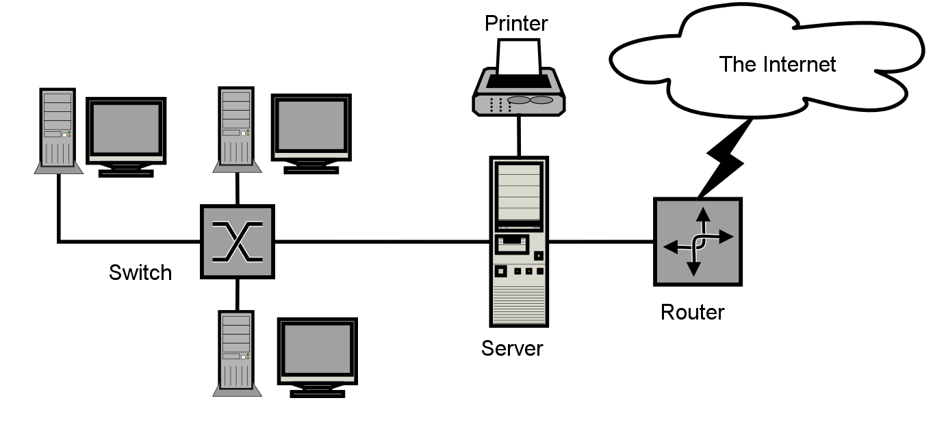**THE INTERNET**

The Internet has revolutionized many aspects of our daily lives. It has affected the way we do business as well as the way we spend our leisure time. Count the ways you've used the Internet recently. Perhaps you've sent electronic mail (e-mail) to a business associate, paid a utility bill, read a newspaper from a distant city, or looked up a local movie schedule-all by using the Internet. The Internet is a communication system that has brought a wealth of information to our fingertips and organized it for our use.

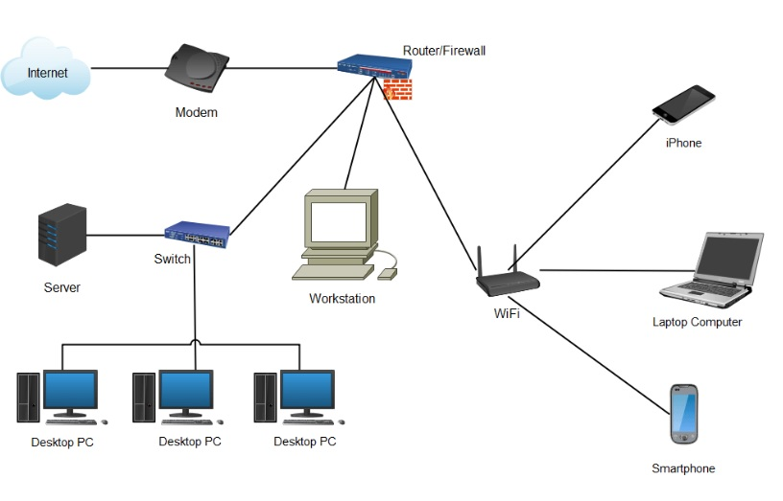

1. **Rack Server Dell R710**
2. **Internet Bandwidth** **:** 700 Mbps (1:1) Dedicated Lease line
3. **Internet Connection distributed to the users through Server :** DHCP Server (Automatic & Manually)
4. **Firewall and Bandwidth Management through :** Smart Guard (Third Party Server)
5. **Distribution of LAN** through Giga switch & UTP Cable

## Deploying soc in college ( Coer University):

Deploying a Security Operations Center (SOC) in a college environment like Coer University involves several critical steps to effectively manage and mitigate cybersecurity risks.

1. Assessment and Planning:

Assess Current Security Posture: Evaluate existing security measures, policies, and infrastructure to identify weaknesses, potential threats, and areas needing improvement.

Define Objectives: Determine the specific security goals and the scope of the SOC, considering the university's network size, critical assets, and potential risks.

2. Designing the SOC:

Infrastructure Planning: Plan the physical and virtual infrastructure needed for the SOC, including hardware, software, network equipment, and security tools (SIEM, IDS/IPS, firewalls, etc.).

Tool Selection: Choose appropriate security technologies that align with the university's security requirements and budget.

3. Team Establishment:

Staffing: Hire or assign skilled personnel with expertise in cybersecurity, incident response, threat analysis, and SOC operations.

Training: Provide continuous training to the SOC team to keep them updated with the latest threats and technologies.

4. Implementation and Deployment:

Deploy Security Tools: Install, configure, and integrate selected security tools and technologies within the university's network.

Establish Processes: Develop standard operating procedures (SOPs) for incident handling, escalation, and response workflows.

5. Monitoring and Response:

Continuous Monitoring: Monitor network traffic, logs, and security events around the clock using the deployed security tools.

Incident Response: Establish a defined incident response plan to handle security incidents promptly and efficiently.

6. Testing and Optimization:

Simulated Exercises: Conduct simulated security exercises to test the SOC's readiness and effectiveness in responding to various cyber threats.

Refinement: Based on test results and real-world feedback, refine configurations, rules, and procedures to improve SOC performance.

Deploying a SOC in a college environment like Coer University requires a combination of technology, skilled personnel, robust processes, and continuous improvement efforts to effectively protect the network, sensitive data, and ensure a resilient security posture against evolving cyber threats. Adapt these steps according to the specific needs and resources available within the university environment. Consulting with cybersecurity experts or service providers might also be beneficial in this process.

**Threat Intelligence :**

Threat intelligence refers to information collected, analyzed, and interpreted to understand potential or existing cyber threats, including the tactics, techniques, and procedures (TTPs) employed by threat actors. It serves as a critical component of cybersecurity strategies, providing valuable insights that enable organizations to proactively defend against threats and mitigate risks effectively.

key aspects and components of threat intelligence:

1. Types of Threat Intelligence:

Strategic Intelligence: Focuses on broader trends, motivations, and intentions of threat actors, helping organizations anticipate future threats.

Tactical Intelligence: Provides specific details about threats, such as indicators of compromise (IOCs), attack patterns, vulnerabilities, and methods used by adversaries.

Operational Intelligence: Offers actionable information for immediate use, aiding in real-time threat detection, incident response, and mitigation strategies.

2. Sources of Threat Intelligence:

Open-Source Intelligence (OSINT): Publicly available information from forums, social media, websites, and news sources that can provide valuable insights into threat actor behavior.

Closed Sources: Information obtained from private or subscription-based services, industry-specific groups, sharing communities, and security vendors.

Technical Feeds: Data derived from security tools, malware analysis, intrusion detection systems, and SIEM platforms within an organization's network.

3. Collection and Analysis:

Aggregation: Gathering diverse data sets from multiple sources, including logs, reports, feeds, and threat feeds.

Normalization: Standardizing collected data into a common format for consistency and ease of analysis.

Correlation: Identifying relationships and patterns within the collected data to uncover potential threats and understand the context of attacks.

**4. Utilization of Threat Intelligence:**

Threat Detection: Using intelligence to identify potential threats by matching indicators against network activity, logs, and security events.

Incident Response: Assisting in rapid response and mitigation efforts during security incidents by providing actionable information to contain and eradicate threats.

Risk Management: Informing risk assessments and aiding in the prioritization of security measures and resource allocation based on identified threats.

**5. Challenges and Considerations:**

Timeliness and Relevance: Ensuring that threat intelligence remains current, accurate, and relevant to the organization's specific threat landscape.

Data Overload: Managing and prioritizing large volumes of threat data to focus on the most critical threats to the organization.

Sharing and Collaboration: Encouraging information sharing and collaboration among industry peers and trusted communities to enhance collective defense against threats.

**6. Continuous Improvement:**

Feedback Loop: Incorporating lessons learned from incidents and threat intelligence usage to improve processes, tools, and response capabilities.

Adaptation: Evolving threat intelligence strategies to address emerging threats and evolving tactics used by threat actors.

**INCIDENT RESPONSE :**

Incident response in cybersecurity refers to the structured approach and actions taken by organizations to manage and mitigate the impact of security incidents. These incidents may include cyber attacks, data breaches, system compromises, malware infections, unauthorized access, or any other security breaches that could potentially harm an organization's IT infrastructure, data, or operations.

Best practices involved in incident response:

1. Preparation:

Develop an Incident Response Plan (IRP): Create a detailed plan that outlines the steps to be taken in the event of a security incident. Define roles, responsibilities, communication protocols, and escalation procedures.

Establish Incident Response Team: Formulate a team of skilled individuals responsible for handling incidents. This team should consist of IT professionals, security experts, legal advisors, public relations, and relevant stakeholders.

Training and Drills: Provide regular training and conduct simulated drills to ensure the incident response team is well-prepared and familiar with their roles and the IRP.

2. Detection and Analysis:

Incident Identification: Use security tools, monitoring systems, and anomaly detection to identify potential security incidents or breaches.

Incident Triage: Assess and prioritize incidents based on severity, impact, and potential risks to the organization's assets and operations.

Forensic Investigation: Conduct in-depth analysis and forensic examination of affected systems and networks to determine the nature and scope of the incident.

3. Containment, Eradication, and Recovery:

Containment: Take immediate actions to limit the scope and spread of the incident. Isolate affected systems or networks to prevent further damage.

Eradication: Remove the root cause of the incident from the affected systems or networks. Patch vulnerabilities, remove malware, or implement necessary fixes.

Recovery: Restore affected systems and data to their normal operational state. Implement backups if necessary.

4. Communication and Reporting:

Internal Communication: Maintain clear and timely communication within the incident response team and relevant stakeholders throughout the incident handling process.

External Communication: Notify appropriate parties, such as law enforcement, regulatory bodies, customers, or partners, as required by regulations or based on the incident severity.

Documentation: Document all actions taken, findings, and lessons learned during the incident response process for future reference and improvement.

5. Post-Incident Analysis and Improvement:

Lessons Learned: Conduct a thorough review and analysis of the incident response process. Identify strengths, weaknesses, and areas for improvement.

Updates to IRP: Update the incident response plan, policies, and procedures based on the findings and lessons learned from the incident.

Continuous Improvement: Implement changes and enhancements to strengthen the organization's incident response capabilities and resilience against future incidents.

Having a well-defined incident response plan, a trained team, and a proactive approach to incident handling is crucial for minimizing the impact of security incidents and maintaining the organization's security posture.

QRADAR :

QRadar is a comprehensive Security Information and Event Management (SIEM) solution designed to provide advanced security intelligence and analytics capabilities for threat detection, incident response, and compliance management. It helps organizations detect, prioritize, and respond to potential cybersecurity threats more effectively by aggregating and correlating data from various sources within the IT environment.

Key features of IBM QRadar include:

1. Log Management and Collection:

QRadar collects and aggregates log data from network devices, servers, applications, endpoints, and security appliances. It normalizes and stores this data for analysis and correlation.

2. Real-Time Event Correlation:

QRadar employs advanced correlation techniques to identify potential security threats by analyzing and correlating security events and logs in real-time. This allows for the detection of anomalous activities and suspicious patterns.

3. Threat Intelligence Integration:

It integrates with external threat intelligence feeds to enrich its capabilities in detecting and responding to known threats, indicators of compromise (IOCs), and emerging attack patterns.

4. Anomaly Detection and Behavioral Analysis:

QRadar utilizes machine learning and behavioral analytics to identify deviations from normal behavior within the network. This helps in detecting insider threats and advanced persistent threats (APTs).

5. Incident Response and Workflow Orchestration:

It provides incident response capabilities by enabling security teams to orchestrate response actions, automate workflows, and initiate response procedures to contain and mitigate security incidents.

6. Visualization and Reporting:

QRadar offers dashboards, visualizations, and customizable reports that provide insights into security events, trends, and compliance posture. This assists in decision-making and regulatory compliance.

7. Integration and Extensibility:

It integrates with various security tools, third-party solutions, and threat intelligence platforms, allowing for a holistic security ecosystem. QRadar also supports customization and extensions through APIs for tailored use cases.

8. Threat Hunting and Investigation:

QRadar facilitates threat hunting activities by enabling security analysts to perform in-depth investigations, conduct searches, and analyze security data to uncover hidden threats or suspicious activities.

IBM QRadar is a powerful SIEM solution that helps organizations improve their cybersecurity posture by providing real-time visibility, advanced threat detection, and effective incident response capabilities across their IT infrastructure. Its comprehensive features make it a valuable tool in managing and mitigating cybersecurity risks.

**Conclusion :**

**Stage 1 :**

Stage 1 involves understanding Common Weakness Enumeration (CWE), OWASP Top Ten vulnerabilities, and the SANS Top 20. CWE catalogs software weaknesses, aiding in vulnerability identification, while OWASP Top Ten highlights critical web application security risks. SANS Top 20 focuses on prevalent cybersecurity threats and mitigation strategies. This learning emphasizes the importance of secure coding practices, threat modeling, and vulnerability management. Recognizing these vulnerabilities enables preemptive measures, like input validation, authentication mechanisms, and patch management, enhancing overall software and system security. Understanding these frameworks aids in proactively addressing vulnerabilities, mitigating risks, and fortifying against potential cyber threats.

**Stage 2 :**

After hands-on experience with Nessus in Stage 2, individuals gain practical insights into conducting web application testing. This experience proves helpful in understanding vulnerabilities specific to web applications, such as SQL injection, cross-site scripting (XSS), and security misconfigurations. It facilitates the identification of weaknesses within web app architectures and helps in comprehending how vulnerabilities manifest are detected by scanning tools like Nessus. Practical application with Nessus enhances skills in mitigating web-related security risks and aids in developing proactive measures to secure web applications effectively.

**Stage 3 :**

The Security Operations Center (SOC) is the operational hub responsible for managing and responding to cybersecurity threats. The SIEM, such as IBM QRadar, serves as a crucial tool within the SOC, providing comprehensive capabilities for collecting, analyzing, and responding to security events and incidents. The QRadar Dashboard, as a part of the SIEM, offers a user-friendly and customizable interface for security analysts and stakeholders to gain valuable insights into the organization's security landscape, aiding in effective decision-making and incident response.

These components work together to empower organizations in proactively identifying, mitigating, and responding to cyber threats, enhancing their security posture, and ensuring the resilience of their IT infrastructure against evolving security challenges.

**Future Scope :**

**Stage 1 :**

The future scope involves integrating these resources into AI-driven vulnerability detection systems, fostering rapid and accurate identification of emerging threats. Aligning with evolving compliance standards, these frameworks will continue to guide secure software development practices, fortifying applications against known vulnerabilities. Collaboration and community-driven knowledge sharing will further enrich these resources, enhancing collective defense against evolving cyber threats.

**Stage 2 :**

Hands-on experience with Nessus in Stage 2 paves the way for an expanded cybersecurity landscape. The future scope involves leveraging advanced features of Nessus for more intricate vulnerability assessments and compliance checks. Integrating Nessus with AI-driven automation will streamline vulnerability detection processes, enhancing efficiency and accuracy. Utilizing Nessus in cloud environments and IoT ecosystems will broaden its applicability, securing diverse technological landscapes. Collaborative innovation and community-driven contributions will further enrich Nessus capabilities, addressing evolving cyber threats and bolstering organizations' defenses.

**Stage 3 :**

A Security Operations Center (SOC) serves as the nerve center for an organization's cybersecurity efforts, housing skilled personnel, processes, and technologies aimed at detecting, analyzing, and responding to potential security threats. Security Information and Event Management (SIEM) solutions, such as IBM's QRadar Dashboard, play a vital role within a SOC by aggregating, correlating, and analyzing vast amounts of security data from various sources within an organization's network. The QRadar Dashboard, as part of the SIEM platform, offers a user-friendly interface that presents actionable insights, visualizations, and reports, aiding security analysts in monitoring security events, identifying anomalies, and making informed decisions to fortify the organization's security posture and swiftly respond to potential cyber threats.

**TOPICS EXPLORED :**

* Active and Passive Attacks
* Phases of Hacking
* Top Ten Hackers
* Networking
* Different Ports
* Subnetting
* Linux Architecture
* Characteristics and Types of Linux OS
* Linux File System and Directories
* Top 20 Sans
* CWE Vulnerabilities
* Web Application Testing
* Nessus Essential
* Burp Suit
* SOC
* SIEM
* IBM QRadar

**TOOLS AND HANDS-ON EXPLORED:**

* Nessus Essential
* VMware
* Kali Linux Installation
* Metasploitable
* SQL Injection
* SOC Tool
* SIEM Tool
* QRadar